NEW ENGLAND INSTITUTE OF TECHNOLOGY

Information Technology Department

Quest #6

Data Structures and Algorithms (SE 394)
Due: Week #6



Joshua LeGoff

Developer

10/30/2015

Date

George Saban

Instructor
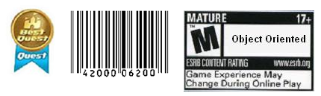

Requirements:

Instructions:
- According to some research, industry values documentation, and excellent written and oral communication skills. The purpose of this part of the class is to encourage you to gain these skills.
- Backup your work to your USB drive for this material may come out as part of your examination.
- Make a copy of this entire document and add your work into it.
- Submit to Blackboard at the same link where you got this document.
- Points will be a deducted if submitted on the wrong place, or if these instructions are not followed.
- [You can earn a maximum of 40 points for this lab. Refer to the syllabus for late point deductions.]

Problem Statement

Part I: | – This will reinforce your understanding of recursion.

Fibonacci numbers – A sequence of Fibonacci numbers is defined as follows:
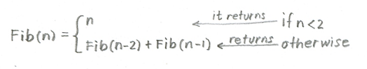

So if the number is 0 (which is less than 2) then it returns the number itself (which is 0). If the number is 1 (which is less than 2) then it returns the number itself (which is 1). However, if the number is 2 (not less than 2) then it returns 0 and 1 (which is n-2 and n-1 respectively). If the number is 3 (which is not less than 2) then it will return n-2 (which is 3-2 = 1) and n-1 (which is 3-1 = 2).

The definition states that if the first two numbers are 0 and 1, then any number in the sequence is the sum of its two predecessors. But these predecessors are in turn sums of their predecessors, and so on, to the beginning of the sequence. The sequence produced by the definition is

0, 1, 1, 2, 3, 5, 8, 13, 21, 34, 55, 89, …

Example, to compute the Fib(6), based on the definition, the computation runs as follows:
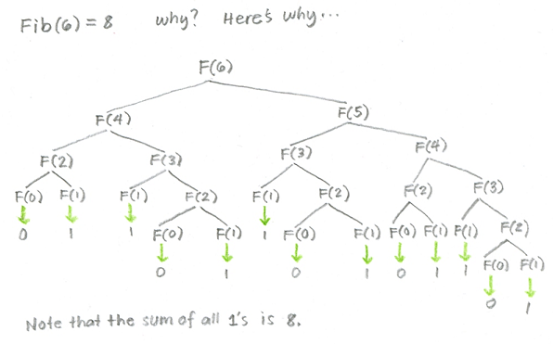
- Create a tree diagram (similar to the above) for Fib(7). Meaning draw your Fibonacci tree by hand and scan, or use MsPaint or other graphical program to draw it. The purpose of this step is to make sure that you understand it.
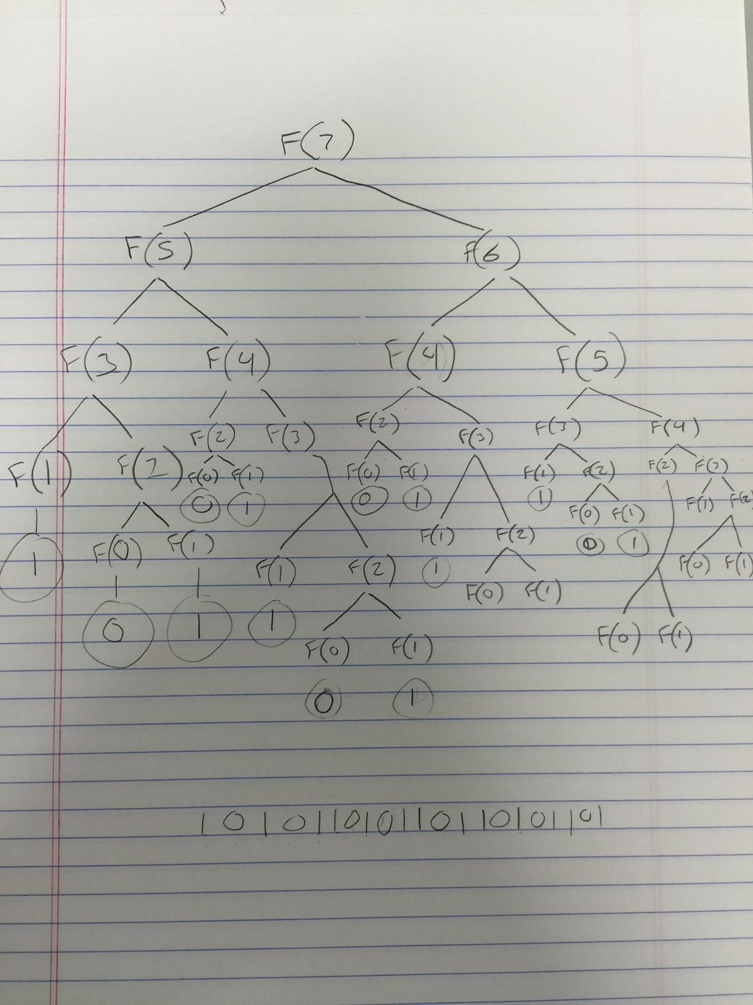
- Based on the tree diagram you’ve created in (a) what is the Fibonacci of 7 equals to?
  - 13
- Implement the Fibonacci’s algorithm in Java by creating a recursive function Fib() that accepts an int and returns an int. Use the main method to drive and test your algorithm.

Code Development:
package Exercise6_1;

public class RecursiveFunction {

public static void main(String[] args) {
// TODO Auto-generated method stub
double y = Fib(7);
System.out.println(y);
}

static double Fib(int n){
if( n < 2 )
return n;

return (Fib(n - 2) + Fib(n - 1));
}

}

Testing:
What is testing for? Every program you wrote, you are responsible for unit testing it. The first thing to do, once you have a program that “basically works”, is to try to break it. Try to feed your program input(s) in the hope of getting it to misbehave. By “hope” means that the challenge here is to find as many errors as possible, so that you can fix the errors before anybody else finds them. If you go into this exercise with the attitude that “my program works, and I don’t make errors!”, then you won’t find many bugs, and you will feel bad when you do find one or when someone finds one. You’d be playing head games with yourself! The right attitude when testing is, “I’ll break it! I’m smarter than any program--even my own!”
Feed (or try) a few such “problematic” inputs to your program and try to figure out in how many ways you can get it to misbehave. Can you get the program to crash? Testing is a very important part of game development, and can actually be fun. You may input data that is not “sensible”. A program ideally catches all errors, not just the sensible ones--this will make your program resilient against “strange input.”
As a goal, you would like the test to exercise every statement in your program, at least once. Test both positive and negative scenario. One example of positive testing is--if you have an input that requires an integer value, would it work if you give it the numeral 7? Moreover, as an example of negative testing: what happens if you give the previous program a string input of “seven” (instead of the numerical 7)? Identify if your test results are “Passed” or “Failed”. Use the table below, and add at least five test cases of your own!
[Type at least 5 test cases and what was the result? Did the result pass or fail? Do a negative test case too!]
Test # | Test Description | Result  (Passed/Failed)
1 | Pass int 7 to Fib | Passed
2 | Pass int 8 to Fib | Passed
3 | Pass double 8.0 to Fib | Failed
4 | Pass string “7” to Fib | Failed
5 | Pass string “seven” to Fib | Failed
 | Add as many rows as needed.

Production Deployment:
[Paste all your own final screens in this section.] Make sure your output screen shot is readable, magnify if necessary so the instructor can easily read it. A sample magnified output is shown below; replace this with your own.
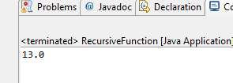

- Implement a non-recursive (meaning, using iterative loop) version of the Fibonacci algorithm by creating iterativeFib() function that accepts an int and returns an int. Use the main method to drive and test your algorithm.

Code Development:
package Exercise6_2;

public class FibExample {

public static void main(String[] args) {

int y = nonRecFib(7);

System.out.println(y);

}

static public int nonRecFib(int n){

int returnResult = 0;

int fib1 = 1;

int fib2 = 1;

for(int i =2; i < n; i ++)

{

returnResult = fib1 + fib2;

fib2 = fib1;

fib1 = returnResult;

}

return returnResult;

}

}

Testing:
[Type your test cases and what was the result? Did the result passed or failed? Do a negative test case too!]
Test # | Test Description | Result  (Passed/Failed)
1 | Pass int 7 to Fib | Passed
2 | Pass int 8 to Fib | Passed
3 | Pass double 8.0 to Fib | Failed
4 | Pass string “7” to Fib | Failed
5 | Pass string “seven” to Fib | Failed
 | Add as many rows as needed.

Production Deployment:
[Paste all your own final screens in this section.] Make sure your output screen shot is readable, magnify if necessary so the instructor can easily read it. A sample magnified output is shown below; replace this with your own.

Part II: | – This will reinforce your understanding of recursion.

Palindrome – Check recursively if the following objects are palindromes:
  - A word – test that the word “Radar” is accepted as a palindrome.
  - A sentence - (ignoring blanks, lower and uppercase differences, and punctuation marks so that “Madam, I’m Adam” is accepted as a palindrome).
  - During testing, you may hard code a test word or a test sentence as a string, or you may accept a string from the keyboard. Your program should work if given only one word, or if given an entire sentence. Show in your Production Deployment section that your program works for both a word and a sentence.

  - Hint: study how to extract a character from the String class from the Java documentation page http://docs.oracle.com/javase/1.4.2/docs/api/

Code Development:
package Quest;

import java.util.Scanner;

public class RecursivePalindrome {

public static void main(String[] args) {

// TODO Auto-generated method stub

Scanner keyboard = new Scanner(System.in);

String input = "";

while(!input.equalsIgnoreCase("exit")){

System.out.println("Enter word or sentence to check if it is a palindrome. Type 'exit' to exit.");

input = keyboard.nextLine();

if(input.equalsIgnoreCase("exit"))

break;

Palindrome(input.toString());

}

keyboard.close();

System.out.println("Goodbye!");

}

static boolean Palindrome(String s){

s = s.toLowerCase().replace(" ", "").trim().replaceAll("\\p{Punct}", "");

if(s.length() <= 1){

System.out.println("Palindrome!");

return true;

}

if(s.charAt(0) == s.charAt(s.length() - 1) && s.length() > 1){

s = (s.substring(1, s.length() - 1));

Palindrome(s);

return true;

}

System.out.println("Not a palindrome!");

return false;

}

}

Testing:
[Type your test cases and what was the result? Did the result passed or failed? Do a negative test case too!]
Test # | Test Description | Result  (Passed/Failed)
1 | Typed “race car!” which should return true as a palindrome | Failed
2 | Typed “race car” after adding code for removing punctuation | Failed
3 | Typed “race car” after adding code for removing spaces | Passed
4 | Typed “race car!” | Passed
5 | Typed “Madam I’m Adam!” | Passed
 | Add as many rows as needed.

Production Deployment:
[Paste all your own final screens in this section.] Make sure your output screen shot is readable, magnify if necessary so the instructor can easily read it. A sample magnified output is shown below; replace this with your own.

GRADING RUBRIC
Grading Criteria | 3  Exceeds  Excellent  Epic Wow | 2  Meets  Satisfactory  O.K. | 1  Partially Meets  Below Expectations  Not Yet | 0  Does Not Meet  Unacceptable  Fail
Coding | +10-Code is excellent, comments are added, and program works. | +8-Code is O.K., and program works. | +6-Code works, but still needs improvement. | Unfortunately, no coding.
Output | +10-Outputs are correct, and provided additional output cases. | +8-Output meets requirement and is readable. | +6-There is output, but not readable, and/or needs improvement. | Unfortunately, no output.
Testing | +10-Test cases were excellent, and provided more test cases than required. | +8-Provided valid tests, and meets minimum test case requirements. | +6-Test needs improvement, did not make sense, and did not meet minimum test case requirements. | Unfortunately, no testing.
Documentation | +10-Excellent documentation. | +8-Documentation meets requirements. | +6-Documentation has misspelling, or syntax issues, or not clear, or needs improvement. | Unfortunately, no documentation.
Late | Excellent, you submitted it before the deadline. | -5, for submitting after the deadline. | -10, for submitting several weeks after the deadline. | -15, unfortunately, for submitting very late.

